Syeda Reeha Quasar

14114802719

4C7

Topics Covered

Java Control statements, Command line arguments

Lab - 2

Java Programming Lab

# **EXPERIMENT – 2.1**

## **Aim:**

WAP to check Vowel or Consonant using Switch Case.

## **Theory:**

The alphabets A, E, I, O and U (smallcase and uppercase) are known as Vowels and rest of the alphabets are known as consonants. Here we will write a java program that checks whether the input character is vowel or Consonant using [**Switch Case in Java**](https://beginnersbook.com/2017/08/java-switch-case/).

**Example: Program to check Vowel or Consonant using Switch Case**

In this program we are not using [break statement](https://beginnersbook.com/2017/08/java-break-statement/) with cases intentionally, so that if user enters any vowel, the program continues to execute all the subsequent cases until Case 'U' is reached and thats where we are setting up the value of a boolean variable to true. This way we can identify that the alphabet entered by user is vowel or not.

**Algorithm:**

1. Enter and Store User Input.
2. Duplicate the input and store it.
3. Change the Case of the duplicate for lesser comparison and uniformity.
4. Pass the input through Switch-Case construct.
5. Check for Vowel.

Print the Result accordingly.

**Concepts:**

* **class** keyword is used to declare a class in Java.
* **public** keyword is an access modifier that represents visibility. It means it is visible to all.
* **static** is a keyword. If we declare any method as static, it is known as the static method. The core advantage of the static method is that there is no need to create an object to invoke the static method. The main() method is executed by the JVM, so it doesn't require creating an object to invoke the main() method. So, it saves memory.
* **void** is the return type of the method. It means it doesn't return any value.
* **main** represents the starting point of the program.
* **String[] args** or **String args[]** is used for [command line argument](https://www.javatpoint.com/command-line-argument). We will discuss it in coming section.
* **System.out.println()** is used to print statement. Here, System is a class, out is an object of the PrintStream class, println() is a method of the PrintStream class. We will discuss the internal working of [System.out.println()](https://www.javatpoint.com/system-out-println-in-java) statement in the coming section.
* **Java Utils:** Resources Job Search Discussion. Java. util package contains the **collections framework, legacy collection classes, event model, date and time facilities, internationalization, and miscellaneous utility classes**. This reference will take you through simple and practical methods available in java.
* util. Java util package contains **collection framework, collection classes**, classes related to date and time, event model, internationalization, and miscellaneous utility classes. ... On importing this package, you can access all these classes and methods.
* **Scanner** is a class in **java.** **util package used for obtaining the input of** the primitive types like int, double, etc. and strings. ... To create an object of Scanner class, we usually pass the predefined object System.in, which represents the standard input stream.
* A switch statement **allows a variable to be tested for equality against a list of values**. Each value is called a case, and the variable being switched on is checked for each case.
* The input is **the data that we give to the program**. The output is the data what we receive from the program in the form of result. Stream represents flow of data or the sequence of data.

## **Source Code:**

import java.util.Scanner;

public class CheckVowelSwitchcase {

public static void main(String args[]) {

char ch;// variable declaration

Scanner scan = new Scanner(System.in);

// create a scanner object for input

System.out.println("Enter the Alphabet for check vowel or consonant ");

ch = scan.next().charAt(0);

;// store the input from the user

switch (ch) {

// check lower case vowel letters

case 'a':

System.out.println(ch + " is a vowel");

break;

case 'e':

System.out.println(ch + " is a vowel");

break;

case 'i':

System.out.println(ch + " is a vowel");

break;

case 'o':

System.out.println(ch + " is a vowel");

break;

case 'u':

System.out.println(ch + " is a vowel");

break;

// check upper case vowel letters

case 'A':

System.out.println(ch + " is a vowel");

break;

case 'E':

System.out.println(ch + " is a vowel");

break;

case 'I':

System.out.println(ch + " is a vowel");

break;

case 'O':

System.out.println(ch + " is a vowel");

break;

case 'U':

System.out.println(ch + " is a vowel");

break;

default:

System.out.println(ch + " is a consonant");

break;

}

}

}

## **Output:**

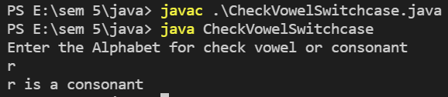



# **EXPERIMENT – 2.2**

## **Aim:**

WAP to display first n prime numbers.

## **Theory:**

We have taken a while loop which acts like a counter means as soon as we get a prime number the i value will be incremented. Then we have taken a for loop for taking every number. The if condition is done so as to make sure that if the no is prime or not. Flag variable is used which signals us that if number taken is prime or not.

**Concepts:**

* **class** keyword is used to declare a class in Java.
* **public** keyword is an access modifier that represents visibility. It means it is visible to all.
* **static** is a keyword. If we declare any method as static, it is known as the static method. The core advantage of the static method is that there is no need to create an object to invoke the static method. The main() method is executed by the JVM, so it doesn't require creating an object to invoke the main() method. So, it saves memory.
* **void** is the return type of the method. It means it doesn't return any value.
* **main** represents the starting point of the program.
* **String[] args** or **String args[]** is used for [command line argument](https://www.javatpoint.com/command-line-argument). We will discuss it in coming section.
* **System.out.println()** is used to print statement. Here, System is a class, out is an object of the PrintStream class, println() is a method of the PrintStream class. We will discuss the internal working of [System.out.println()](https://www.javatpoint.com/system-out-println-in-java) statement in the coming section.
* **Scanner** is a class in **java.** **util package used for obtaining the input of** the primitive types like int, double, etc. and strings. ... To create an object of Scanner class, we usually pass the predefined object System.in, which represents the standard input stream.

## **Source Code:**

import java.util.*;

class primeN {

public static void main(String args[]) {

Scanner sc = new Scanner(System.in);

int i, n, p, count, flag;

System.out.println("Enter the number of prime terms you want!");

n = sc.nextInt();

System.out.println("First " + n + " prime numbers are :-");

p = 2;

i = 1;

while (i <= n) {

flag = 1;

for (count = 2; count <= p - 1; count++) {

if (p % count == 0) // Will be true if p is not prime

{

flag = 0;

break; // Loop will terminate if p is not prime

}

}

if (flag == 1) {

System.out.print(p + " ");

i++;

}

p++;

}

}

}

## **Output:**

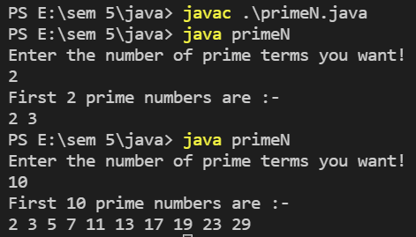

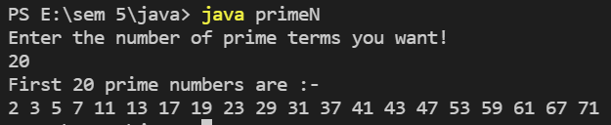

# **EXPERIMENT – 2.3**

## **Aim:**

WAP to check whether the input year is leap or not.

## **Theory:**

Enter any year as an input. We first whether the given year is divisible by 400 or not. If it is divisible then it is a leap year else, we check for further conditions. Now if it is divisible by 100 then it is not a leap year or else, we further divide it by 4. If it is divisible then it is a leap year else it’s not.

Here is the source code of the Java Program to Find if a Given Year is a Leap Year. The Java program is successfully compiled and run on a Windows system. The program output is also shown below.

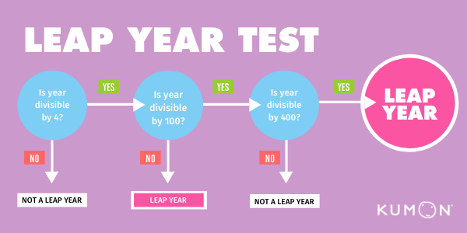

A leap year is a calendar year that contains an additional day added to keep the calendar year synchronized with the astronomical year or seasonal year.

## **Source Code:**

import java.util.Scanner;

public class Check_Leap_Year {

public static void main(String args[]) {

Scanner s = new Scanner(System.in);

System.out.print("Enter any year:");

int year = s.nextInt();

boolean flag = false;

if (year % 400 == 0) {

flag = true;

} else if (year % 100 == 0) {

flag = false;

} else if (year % 4 == 0) {

flag = true;

} else {

flag = false;

}

if (flag) {

System.out.println("Year " + year + " is a Leap Year");

} else {

System.out.println("Year " + year + " is not a Leap Year");

}

}

}

## **Output:**

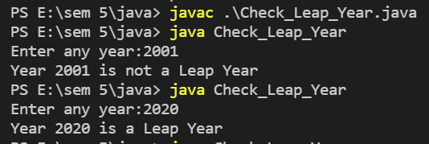

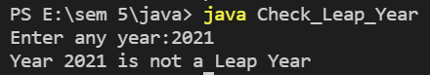



# **EXPERIMENT – 2.4**

## **Aim:**

Write an application that accepts two doubles as its command line arguments, multiple these together and display the product.

## **Theory:**

What Are Command Line Arguments?

## The command-line arguments are passed to the program at run-time. Passing command-line arguments in a Java program is quite easy. They are stored as strings in the String array passed to the args parameter of main () method in Java.

## In fact, command line arguments are using just for a subject purpose and maybe it is used in advance java core system in order to build the applications, just an expectation. Since, there may be a lot of ways to execute the program.

## But it is necessary that you need to know as a newbie about command line arguments.

What are command line arguments?

## The console is an interface between the user and program.

## When a user enters the inputs on the console using commands, we sending the input as an argument to the main method in java that’s why in public static void main() we creating a string array to store values which work at executing time.

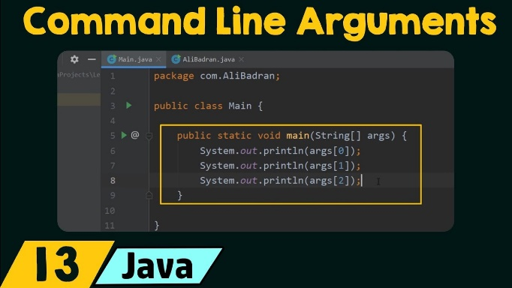

## **Source Code:**

class multiply {

public static void main(String[] args) {

double num1 = Double.valueOf(args[0]);

double num2 = Double.valueOf(args[1]);

System.out.println(num1 * num2);

}

}

## **Output:**

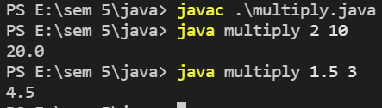



# **EXPERIMENT – 2.5**

## **Aim:**

Write an application that accepts one command line argument, display the line of reporting if number is even or odd.

## **Theory:**

In this program, you'll learn to check if a number entered by an user is even or odd. This will be done using if...else statement and ternary operator in Java.

To understand this example, you should have the knowledge of the following [Java programming](https://www.programiz.com/java-programming) topics:

* [Java if...else Statement](https://www.programiz.com/java-programming/if-else-statement)
* [Java Scanner Class](https://www.programiz.com/java-programming/scanner)
* **Java Utils:** Resources Job Search Discussion. Java. util package contains the **collections framework, legacy collection classes, event model, date and time facilities, internationalization, and miscellaneous utility classes**. This reference will take you through simple and practical methods available in java.
* util. Java util package contains **collection framework, collection classes**, classes related to date and time, event model, internationalization, and miscellaneous utility classes. ... On importing this package, you can access all these classes and methods.
* **Scanner** is a class in **java.** **util package used for obtaining the input of** the primitive types like int, double, etc. and strings. ... To create an object of Scanner class, we usually pass the predefined object System.in, which represents the standard input stream.

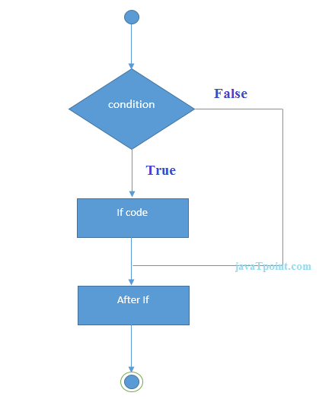

## **Source Code:**

public class EvenOdd {

public static void main(String[] args) {

int num = Integer.valueOf(args[0]);

if (num % 2 == 0)

System.out.println(num + " is even");

else

System.out.println(num + " is odd");

}

}

## **Output:**

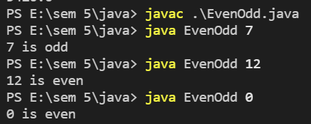



# **EXPERIMENT – 2.6**

## **Aim:**

Write an application that accepts radius of a circle as its command line argument display the area.

## **Theory:**

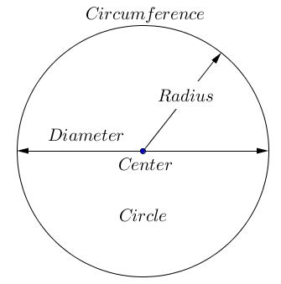

In geometry, the area enclosed by a circle of radius r is πr2. Here the Greek letter π represents a constant, approximately equal to 3.14159, which is equal to the ratio of the circumference of any circle to its diameter.

The circumference of a circle is the linear distance around its edge.

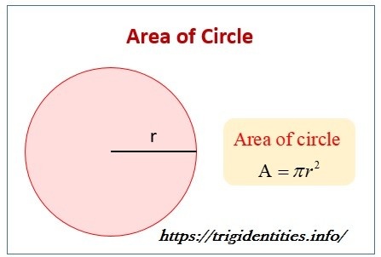

## **Source Code:**

public class CircleArea {

public static void main(String[] args) {

double radius = Double.valueOf(args[0]);

System.out.println("Area of circle with radius " + radius + " is " + (radius * radius * 3.14));

}

}

## **Output:**

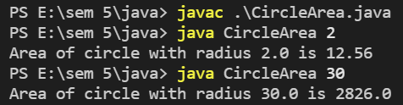



# **Viva Questions**

### **1. What is a pointer and does Java support pointers?**

### Ans.

Pointer is a reference handle to a memory location. Improper handling of pointers leads to memory leaks and reliability issues hence Java doesn't support the usage of pointers.

### **2. What is the base class of all classes?**

Ans.

java.lang.Object

### **3. Does Java support multiple inheritance?**

Ans.

Java doesn't support multiple inheritance.

### **4. Is Java a pure object-oriented language?**

Ans.

Java uses primitive data types and hence is not a pure object-oriented language.

### **5. Are arrays primitive data types?**

Ans.

In Java, Arrays are objects.